**DAILY ONLINE ACTIVITIES SUMMARY**

|  |  |  |  |  |  |  |
| --- | --- | --- | --- | --- | --- | --- |
| **Date:** | | | **04/05/2020** | **Name:** | **JASLINE SHARON TAURO** | |
| **Sem & Sec** | | | **4th sem, A Section** | **USN:** | **4AL18CS029** | |
| **Online Test Summary** | | | | | | |
| **Subject** | **MICROCONTROLLER AND EMBEDDED SYSTEM** | | | | | |
| **Max. Marks** | **20** | | | **Score** | **10** | |
| **Certification Course Summary** | | | | | | |
| **Course** | | | 1. **Trailhead Basics** 2. **Phyton for Machine Learning** | | | |
| **Certificate Provider** | | 1. **SALES FORCE** 2. **GREAT LEARNING** | | **Duration:** | | 1. **3 HRS** 2. **1 HRS** |
| **Coding Challenges** | | | | | | |
| Problem Statement:write a java program to read three integer values from the keyboard and find the sum of the values. Declare a variable "sum" of type int and store the result in it.Write a C++ program to find the missing number in array | | | | | | |
| **Status: DONE** | | | | | | |
| **Uploaded the report in GitHub** | | | | **YES** | | |
| **If yes Repository name** | | | | <https://github.com/jaslinesharontauro/JAVA_Prgms>  <https://github.com/jaslinesharontauro/C_Prgms/blob/master/Missing_Num.cpp> | | |
| **Uploaded the report in slack** | | | | **YES** | | |

**Online Test Details: (Attach the snapshot and briefly write the report for the same)**

**Certification Course Details: (Attach the snapshot and briefly write the report for the same)**

**Coding Challenges Details: (Attach the snapshot and briefly write the report for the same)**

**ONLINE TEST DETAILS:**

**Today’s Internal assessment was based on the subject MICROCONTROLLER AND EMBEDDED SYSTEMS’. Test was conducted on the 3rd module. The test comprised of 20 questions of one mark each, out of which I scored 10.**

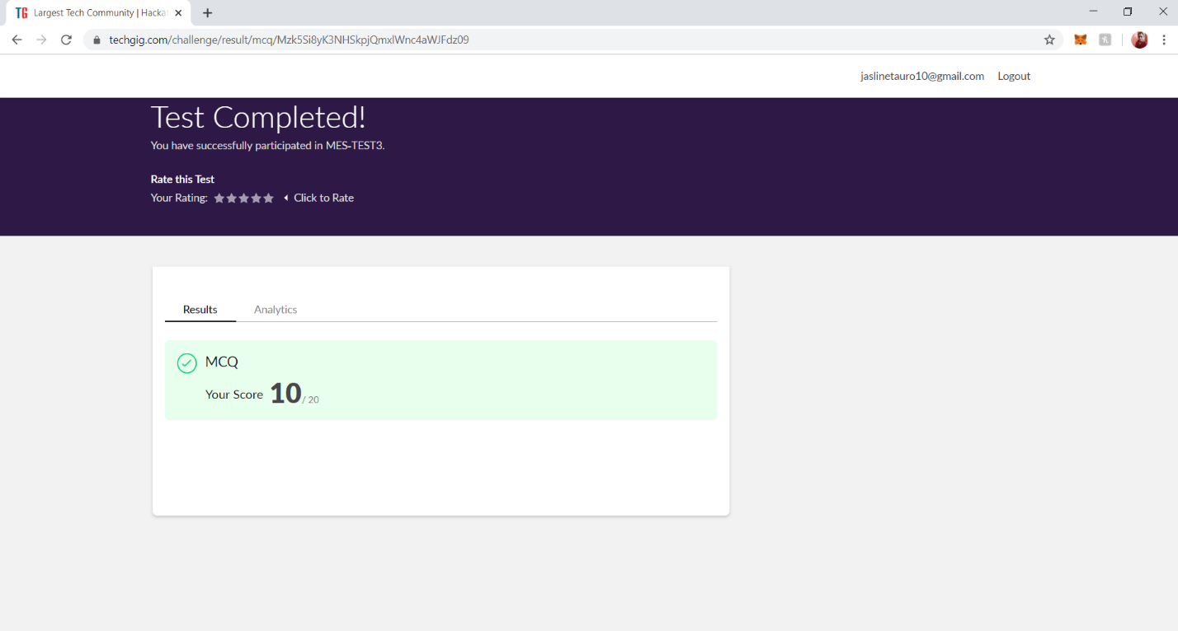

**CERTIFICATION COURSE DETAILS**

**Today I have done certification course on TRAILHEAD BASICS. I learnt about the Picklist administration2. I also learnt how to share values with global value sets and to manage my picklist values.**

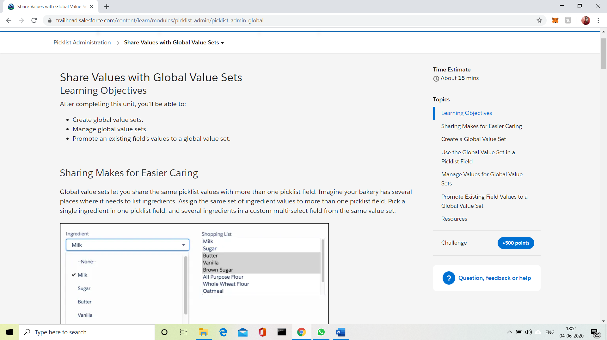

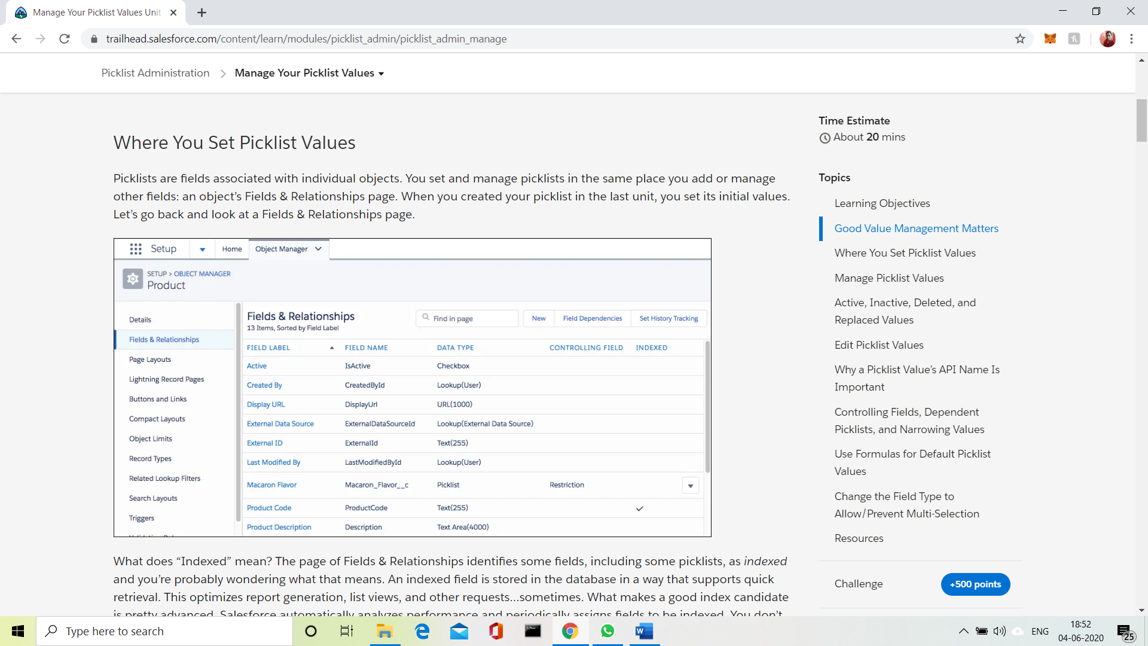

**Also, I have done course of python for machine learning. I have completed all the modules of this course. Tomorrow I have to take up a final assessment of this course. Today I learnt about Lambda functions and its uses and also learnt about Classes and Objects.**

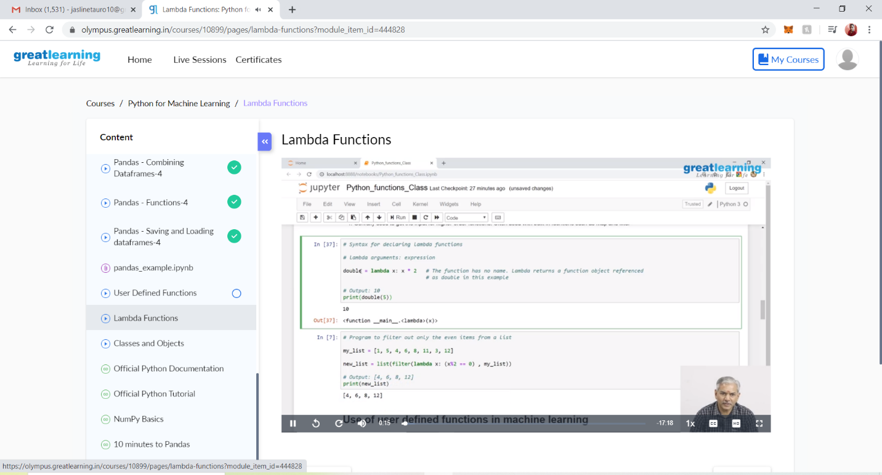

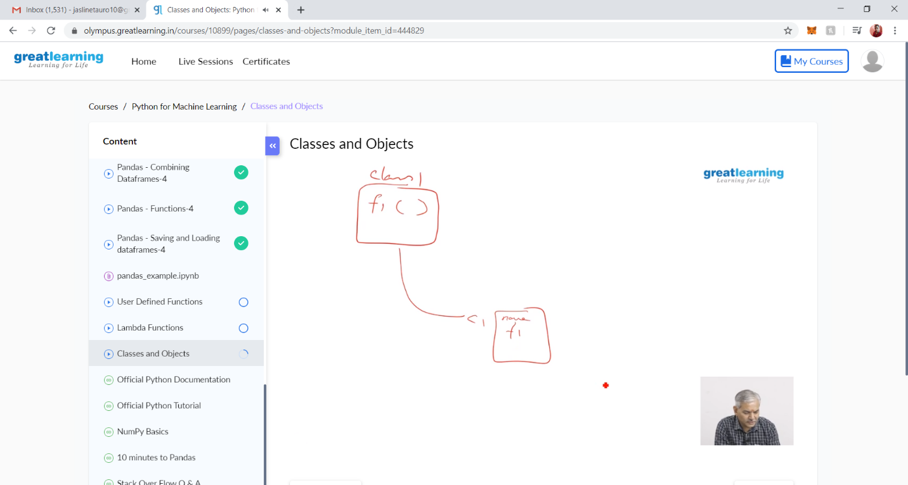

**CODING CHALLENGES DETAILS:**

**Problem statement 1:**

write a java program to read three integer values from the keyboard and find the sum of the values. Declare a variable "sum" of type int and store the result in it.

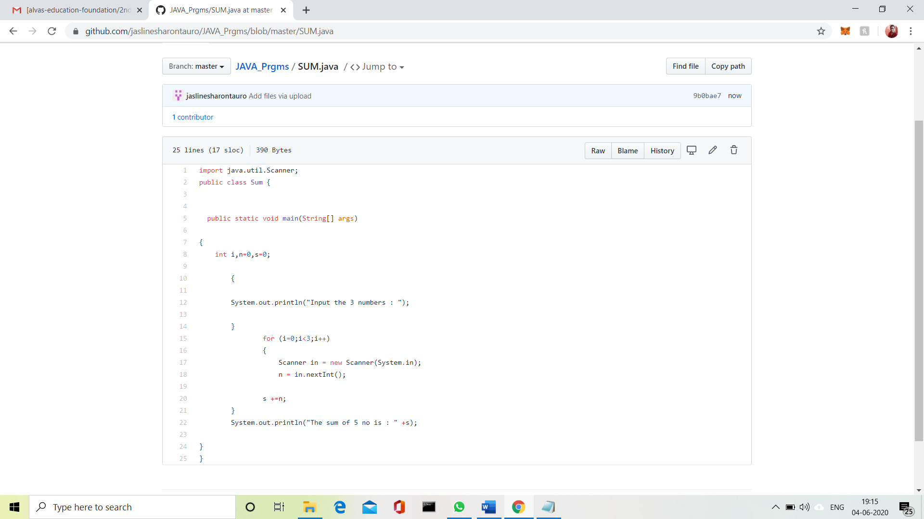

**Problem Statement 2:**

Write a C++ program to find the missing number in array

Given an array C of size N-1 and given that there are numbers from 1 to N with one element missing, the missing number is to be found.

**Input:**  
The first line of input contains an integer T denoting the number of test cases. For each test case first line contains N (size of array). The subsequent line contains N-1 array elements.

**Output:**  
Print the missing number in array.

**Constraints:**  
1 ≤ T ≤ 200  
1 ≤ N ≤ 107  
1 ≤ C[i] ≤ 107

Example:  
Input:  
1  
5  
1 2 3 5

Output:  
4

